Capstone
Whether Quality of Institution or Field of Study Better Predicts Student Loan Repayment

Graham Burns
Colorado State University Global
MIS 581: Capstone – Business Intelligence and Data Analytics
Dr. Justin Bateh
February 6, 2025

Abstract
A postsecondary education is one of the most important tools a young adult can have when starting their career, especially in the United States. In order to pay for such an education, prospective students often need to take out student loans which need to be paid back and an inability to pay these loans back can be detrimental to the future of graduates. To this end, one of this most important choices a student faces when entering postsecondary education is what to study and where. This research investigates which of those factors is more likely to predict an ability to pay back the student loans taken out. The College Scorecard dataset, compiled by the U.S. Department of Education, is used as the backbone of the research and provides a wealth of data to be considered.
The findings from this research show that the quality of the institution, determined by graduation rate and cost of attendance, hold much more predictive qualities than any specific area of study a student chooses. Additional research shows that there are other factors that are even stronger predictors of whether a student can repay their student loans and include family income of the student and earnings after graduation as both are statistically significant predictors. In general it is found that it is difficult to find factors fully within control of the prospective student that can consistently predict the ability to repay student loans and therefore more research is needed to create compound factors to be able to educate students on what they should study and where they should study in order to give themselves the best chance to repay any student loans needed.

Postsecondary Student Loans
Having postsecondary education available to all students after completing high school is incredibly important. A study from Georgetown University (2023), states that “in 2021, 68% of the 155 million jobs in the U.S. required at least some postsecondary education or training, compared to just 32% in 1983”. An important part of making postsecondary education available to all potential students is availability of student loans to those students who do not have the financial means to pay for this. Black, et al. (2020) studied whether increased student loans would have negative effects on students later in life, an important issue as student loan borrowing increases. What Black, et al. found is “increased student loan availability raises student debt and improves degree completion, later life earnings, and student loan repayment”.
Given the aforementioned importance of both postsecondary education and the need for availability to all of student loans to pay for that education, the obvious next consideration is the ability to pay back the loan by the student. Students who need to take out loans are encouraged to do so, however decisions the student makes can determine the ability of the student to repay those loans. Some of those decisions include how much money to take as a loan, where to go to school and what to study.

Objective
Potential postsecondary students are making a big financial decision when deciding whether to take out student loans to pay for their education. A student loan comes with a promise to repay that loan, with interest, and therefore it is incumbent on the student to make decisions that will put them in the best situation to be able to repay those loans. Knowing whether a specific school or a specific area of study would be more likely to be able to repay the student loan taken out would be beneficial for students to be able to decide where and what to study. That is what this research will analyze, along with other factors, so that students can determine if the amount of student loans they need to incur makes sense given what and where they study.

Research Benefits
As mentioned, the benefits of this research will be the ability to further educate prospective students on what the most important factors they must take into consideration will be when they are researching and applying to schools and areas of study. By increasing education, students can make decisions based on data and not solely on recruiting pitches from schools or aptitude tests given to them for future careers. Rosinger (2017) notes, “The next step is for college leaders and researchers to work together to continue to develop and evaluate strategies aimed at helping students make informed borrowing decisions”. This research aims to fulfill the responsibility being put on researchers to help students make better borrowing decisions.

Research Questions
“Interest in a particular topic usually begins the research process, but it is the familiarity with the subject that helps define an appropriate research question for a study.” (Farrugia, et al., 2010) This is a good starting point for deciding on what good research questions would be to partner with the purpose of the research. Being both a student with student loans from postsecondary education and as someone who has attended multiple schools for multiple disciplines, this area of research checks the boxes for both interest and familiarity.
To determine how to create the research questions needed to drive the research, we can look to the FINER method for creating research questions from Hulley et al. (2007). This criteria can be used to highlight specific points that will hopefully increase the likelihood of creating a successful research project.
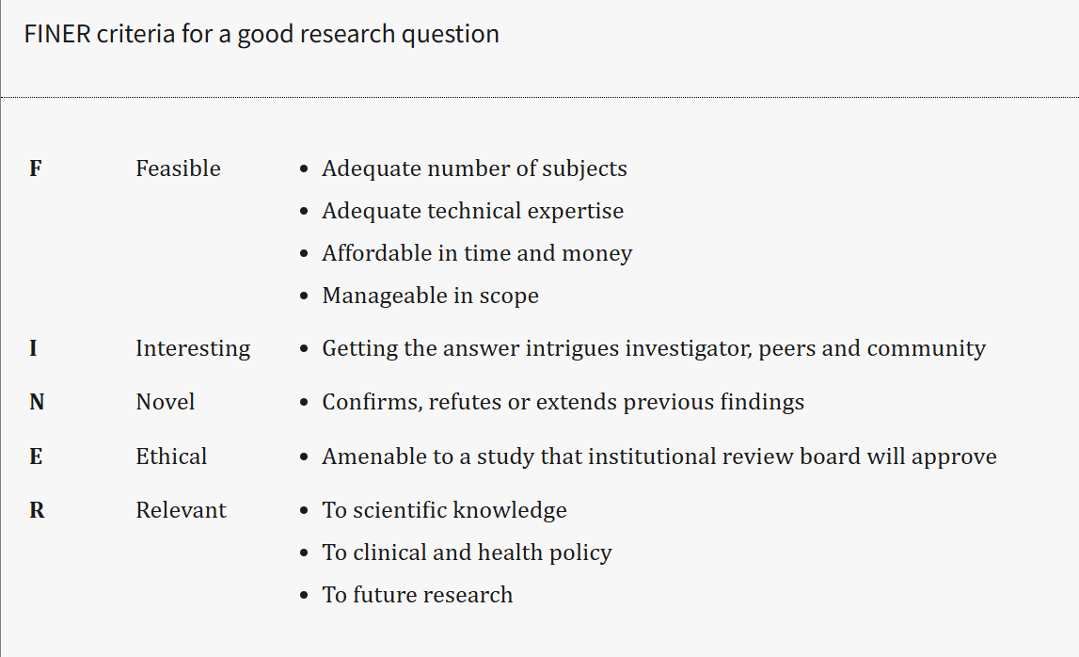
Image 1 – Hulley et al.’s FINER method to research questions
Using the FINER method as a guide here are the research questions that this research will focus on, in order of importance:
- What is a more predictive factor in the likelihood of a student loan being repaid, the quality of the institution attended, or the area of study chosen by the student?
- Is there another factor not currently considered in question one that does a better job at predicting student repayment likelihood other than area of study or quality of institution?
- If there is another factor that does a better job of predicting repayment, is it one that the student can control/impact?
These research questions act as a way of expanding the research pending the outcome of the research on the question preceding it. The first question covers the main point of the research, looking at the quality of an institution and the field of study for a student and determining which, if any, is better at predicting an ability to repay a student loan. Because it is possible there are many factors that could play into that ability to repay, question two looks at other possible factors to see if any have a better chance of predicting this. The third question takes into consideration the many different biases and advantages that are possible to come to light in in the data when looking at predictability and deciding whether the factor that is better at predicting repayment ability is one in the control of the student. If it isn’t, it isn’t a factor worth considering for educating students as it is not one the student can use to decide.

Hypotheses
There is a great deal of importance placed on the use of hypotheses in the research process. This is because being able to hypothesize on what the research might, or is expected, to give as a result shows the starting point that the researcher begins with before actually doing the analysis to see what the research uncovers. Since, as stated before, the researcher should be both interested in the topic of the research, and preferable someone who has a familiarity with the subject, the resulting hypothesis for a research question can be considered the best educated guess of the researcher.
Hernon and Schwartz (2013) give a very good overview of the use of hypotheses and give these characteristics for a good hypothesis, “Hypotheses should be generalizable, apply to more than one situation, be compatible with existing knowledge (i.e., theory), and clearly worded so that they are testable”. The last part is important as any hypothesis needs to be testable in order to be of use.

Hypotheses for Research Questions
Given the research questions already set forth, now those questions need a corresponding null and alternate hypothesis so that the question can be tested against. These are formatted as H₀ for the null hypothesis and H₁ for the alternate hypothesis.
- What is a more predictive factor in the likelihood of a student loan being repaid, the quality of the institution attended or the area of study chosen by the student?
Null Hypothesis(H₀) – The area of study chosen by a student is the best predictor of student repayment likelihood.
Alternate Hypothesis(H₁) – The quality of the institution the student attends is the best predictor of student repayment likelihood.

- Is there another factor not currently considered that does a better job of predicting student repayment likelihood other than area of study or quality of institution?
Null Hypothesis(H₀) – One of area of study or quality of institution will be the best predictor of student loan repayment.
Alternate Hypothesis(H₁) – A different factor not mentioned will prove to be the best indicator of student loan repayment likelihood.

- If there is another factor that does a better job of predicting repayment, is it one the student can control and/or impact?
Null Hypothesis(H₀) – If a factor is deemed to be a better predictor of student loan repayment, it is unlikely to be one that is in control of the student.
Alternate Hypothesis(H₁) – A different factor not mentioned will prove to be the best indicator of student loan repayment and will be something the student has control over.

Literature Review
The crux of a literature review is to become as educated as possible in the topic of the research and to let this review help determine the legitimacy of the research questions that will drive the new research. The first, and main, research question for this paper is “What is a more predictive factor in the likelihood of a student loan being repaid, the quality of the institution attended or the area of study chosen by the student?” and after going through various different searches it was determined that this specific question wasn’t one that showed up in previous research. That doesn’t mean there hasn’t been extensive research on different larger parts of the question though.
For example, a paper by Fitzgerald and Burns (2000) titled ‘ College Quality and the Earnings of Recent College Graduates’ found that differentiating characteristics between institutions could be determined to make a 2% difference in annual earnings for men and a 4% difference for women for those institutions deemed to have premium differentiating characteristics. That difference can add up to a large difference in lifetime earnings, but isn’t as large of a variance as one might expect.
Looking at the Field of Study perspective, a study by Kim et al. (2015), titled 'Field of Study in College and Lifetime Earnings in the United States' determined there was an overwhelming difference in estimated lifetime earnings between different fields of study. One example was a BA in Social Science by males estimated a career earnings gain, versus a high school diploma, at $374,000. A BA in a STEM field by males in comparison would increase that career earnings gain to $800,000 versus a traditional high school diploma. There are also some interesting findings regarding certain fields of study being more prone to increased late-career earnings versus others that show consistent earnings growth throughout the career.
These two studies show the two different factors being considered in the first research question, and though they both use older data in their models, their conclusions can be used to form the null hypothesis that field of study chosen will be a larger predictor of ability to pay off student loans than chosen institution.
Second Research Question
The second research question this project will focus on is “Is there another factor not currently considered that does a better job of predicting student repayment likelihood other than area of study or quality of institution?” There is quite a bit of research of different factors other than quality of institution and field of study on student earnings. One such study is by Dalton (2004) titled, “The impact of academic performance on post-graduation earnings”. This study found that academic performance was a statistically significant predictor of pos-graduation earnings. The researcher does note that the coefficient of return is small, but since it compounds, does have larger implications over the course of a career. Because the coefficient is small, the null hypothesis for this question will be that one of the factors being considered by this study will be a better predictor of student loan repayment than academic performance for example. This is also a positive finding leading into the third research question because invariably academic performance is something that is within the student’s control.
Third Research Question
The final research question considered is “If there is another factor that does a better job of predicting repayment, is it one the student can control and/or impact?” This question is not one that is purely based on statistical analysis, so it was important to look outside only statistical analysis studies and a study by Weeden (2002) titled “Why do some occupations pay more than others? social closure and earnings inequality in the United States” looked form a different perspective. It determined that closure practices that generate tangible restrictions on the labor supply, such as social and legal barriers, shaped the structure of occupational earnings for different fields. These are in large part factors outside of the control of individual students and therefore lead to a null hypothesis that if a factor is deemed to be a better predictor of student loan repayment, it is unlikely to be one that is in control of the student.

Research Design
The data that will be used in this study will be entirely secondary, external data. This is data that the U.S. Department of Education tracks as what is known as the ‘College Scorecard’. This is data that the DoE uses to score its institutions and they make this data available to the public. The data is presented as segregated into two different datasets for easier consumption of data. First there is the Institution level data which splits data out by individual schools and has 6,485 different schools listed. The second dataset presents the data by field of study within those schools. Since every school offers many different fields of study, this dataset is much larger and contains over 223,000 rows of data.
Visual Model
The data dictionaries for the two different datasets being used in this research are quite extensive. The dictionary for the Field of Study dataset has 113 rows of data elements, which is quite extensive and a portion of which can be seen below:
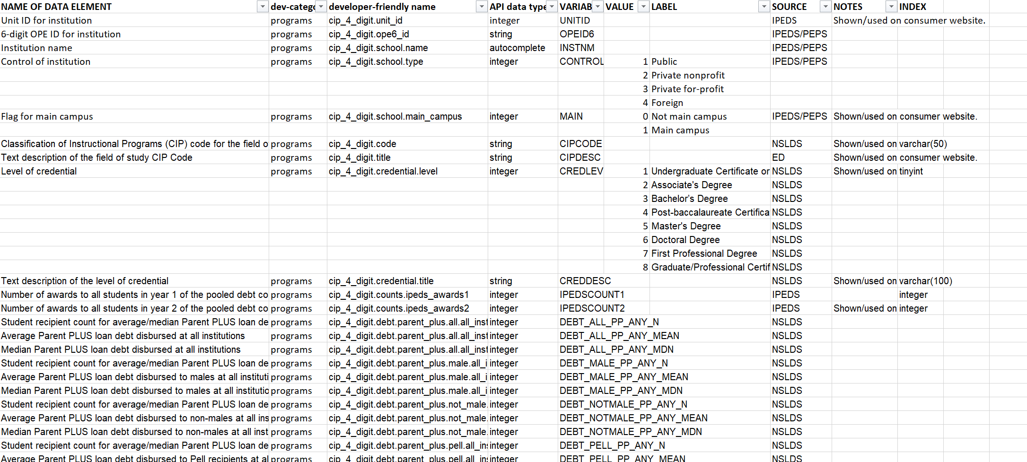
Image 1 – Data Dictionary of Field of Study Dataset

Unlike the relative consiceness of the Field of Study data dictionary, the one for the Institution based dataset is quite extensive. A portion of this is seen below, but it is 3,252 rows of different elements.
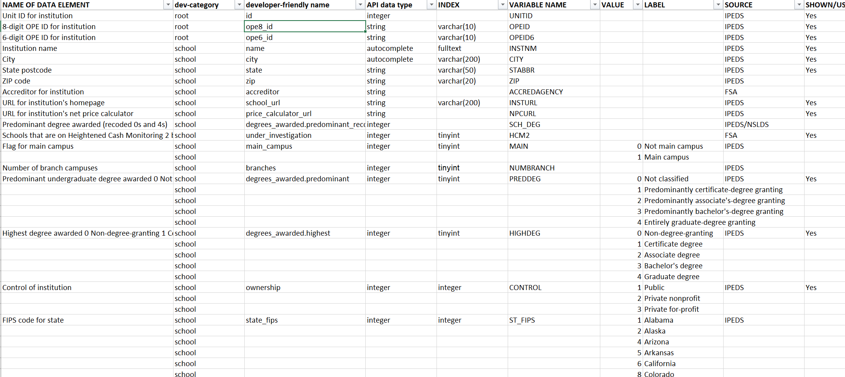
Image 2- Data Dictionary of Institution Dataset
The types of variables represented in these data dictionaries as expected are also quite extensive. Different variable types found in the data dictionaries include Categorical, Continuous, Discrete, Binary, and Derived.

Dataset Constraints
The datasets, though quite extensive, are not without their constraints. There are many elements in the Field of Study dataset that are suppressed due to privacy and need to be cleaned. There are also elements in both datasets that are aggregate results. For example, in the Field of Study dataset, there is an element called ‘Median earnings of students working and not enrolled 10 years after entry in the lowest income tercile $0-$30,000’. This is obviously a derived value that has been created using the raw data from the dataset. This type of data would only be used when a better alternative is not available.

Why This Dataset?
One standard for whether a dataset is a good choice to be used in research is the FAIR standard of data principles. FAIR stands for Findable, Accessible, Interoperable and Reusable. Findable relates to metadata and data to be easy for both humans and machines to find. Accessible covers how easy it is for the dataset to be accessed by individuals looking to use it. Interoperable means how easy the data is to work with, for example does it work well with other data used in research. Reusable is the end goal of dataset construction if it can’t be reused multiple times it doesn’t meet the FAIR standard.
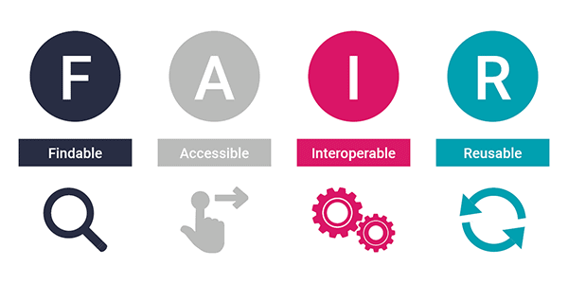
Image 3- FAIR Standard of Data Principles (Schmidt, 2023)
The datasets used for this research, made available by the US Department of Education, are the most comprehensive datasets publicly available for post-secondary institutions and fields of study within those institutions. They do have some issues, as highlighted above, but in the end are the most logical datasets to use for this research. Since the data is collected and created by the Department of Education, there would likely be some biases in the data both from the collection of data and from the inherent biases that the data represents, but as a neutral third-party organization the data should be free of intentional bias by institutions with a financial reason to misrepresent their institution or a particular field of work.

Research Methods
The methodology that will be used will be one focused on experimental design looking into the relationship between independent and dependent variables to determine if there is a statistically significant relationship that would allow the factors being researched to be considered as having a predictive value into the ability to repay student loans.
The research method for the discussed research questions would be different from one question to the next. This is expected as the questions are more or less built off of each other as an extended level of research from one question to the next. For question one, the research method would be to use both comparative and predictive analysis to decide which of the two factors are more likely to predict future ability to repay student loans. Models that are expected to be used for this method are Regression for exploring predictiveness and models such as Random Forests to rank the importance of the factors.
For question two, the research method would be considered more of an exploratory analysis in order to look at possible other factors that are better predicters of repayment ability. The models for this research are expected to be similar with Regression analysis likely done, and more Random Forests done to try to uncover factors that weren’t explored in question one. Lastly, for question three, the method would be less technical analysis and more analysis on the factors themselves and whether an individual student would be able to control this factor. For example, if the best possible predictor is Student’s Parental Household Income, that is something the student themselves can’t control.

Ethical Considerations
The World Health Organization is involved in a lot of research around the world, involving people from all nations and are therefore a good guiding post for understanding the importance of ethics in research. Their stance (WHO, 2025) is, “Research ethics govern the standards of conduct for scientific researchers. It is important to adhere to ethical principles in order to protect the dignity, rights and welfare of research participants”. The main ethical consideration when performing the analysis for the research will be to attempt to avoid discrimination and bias in the models. Because the data may have those biases in them, it will be difficult for the models to not include those same biases. There are tests that can be run to analyze the model’s performance for different demographic groups. This wouldn’t remove any bias that is found, but it may at least reveal it and allow for it to be addressed. The second ethical issue that could be a possibility in doing research such as this would be privacy protection in case there is any PII in the data. Thankfully this data has any and all PII removed, and since it is somewhat aggregated, there is little to no chance of there being any privacy issues with the data.

Empirical Findings
The research begins by deciding what makes one institution of higher learning better than another in the eyes of a perspective student. In order to determine that in a way that could be used for this research it was determined to not consider outside sources such as third-party rankings. Instead it was looked at in its most logical, stripped-down form. Two questions were asked:
1. What is the end goal of all students when deciding to pick a college?
2. Since this study is about repaying student loans, what are student loans used for?
The answers to this led to the two variables that were used to determine the quality of an institution, graduation rate and cost of attendance. Presumably good schools have a high degree of graduation and if you are paying more for one school over another, it can be presumed that one school is better than another.
The first research question: ‘What is a more predictive factor in the likelihood of a student loan being repaid, the quality of the institution attended or the area of study chosen by the student?’ meant a model had to compare cost of attendance and graduation rate against field of study. Unfortunately the two datasets, despite being in the same overall data College Scorecard data collection process, did not have the same length of time for student loan repayment so the longest term was used for both which was a 7-year repayment term for institution data and a 3-year repayment term for field of study data.
The initial model looked solely at the two factors for institution quality and ran them against the 7-year full repayment variable in the dataset. The results were very promising, as both factors showed a healthy importance that was also extremely close to each other, validating the choice of these two factors to determine institution quality:
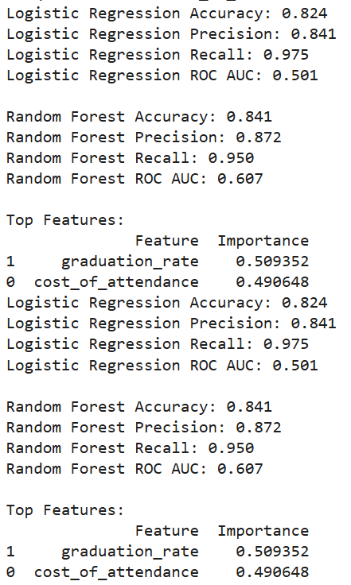
Image 4- Statistical Analysis Output of Institution Quality Factors
The features were both accurate and important in predicting student loan repayment and were within 0.02 of each other in importance rating. For Field of Study analysis had a somewhat similar decision that needed to be made because a determination had to be made about how granular to allow the field of study to be. The determination was made that the 2-digit Program Area was the best factor to use. It is called Classification of Instructional Programs (CIP 2000). This is essentially the roll-up level of all the different fields within an area. For example, code 01 is:
AGRICULTURE, AGRICULTURE OPERATIONS, AND RELATED SCIENCES.

The National Center for Education Statistics makes a page available for each of the different codes to see what are matched the code. Here is a screenshot for this area:

Image 5- NCES Program Area Classifications
This allows the user to scroll through the areas of study to find the right one to correspond to the two-digit number. Using the CIP 200 IDs, the different fields were run against the same regression analysis and random forests as the institutions were, and the results were:
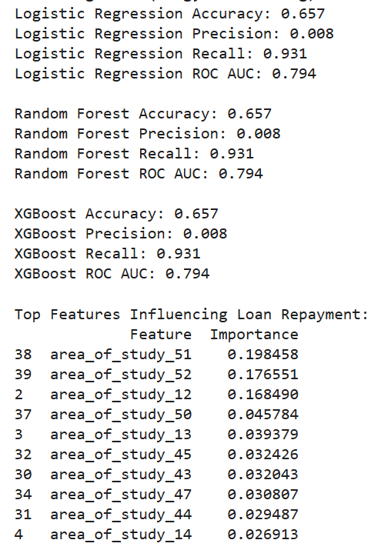
Image 5- Field of Study Independent Analysis
The results are that there isn’t a great deal of accuracy in predcting using any of the areas of study as predictors, though there is great recall. The importance levels are also quite a bit lower than the ones we saw when looking at quality of institution which makes it very hard to accept the null hypothesis in this case. Here are the corresponding codes and areas of study:
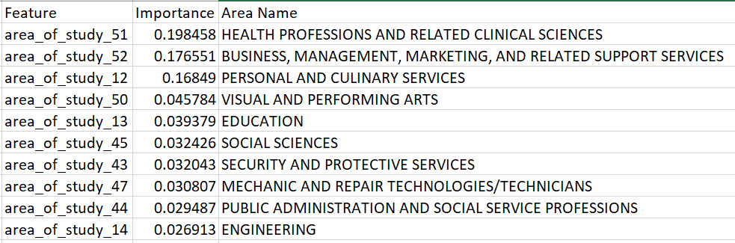
Table 1- CIP 200 code corresponding areas of study
What stands out here is just as much what areas of study aren’t here as which ones are. ENGINEERING was expected to be higher, as was COMPUTER AND INFORMATION SCIENCES AND SUPPORT SERVICES and PERSONAL AND CULINARY SERVICES is a surprise to see so high. There may still be some value in using the field of study results to highlight those areas that are doing much better than the rest which are 51, 52 and 12. Regardless, it is clear that both variables used for considering quality of institution are quantitatively far superior in predicting the ability to repay student loans and therefore the Alternate Hypothesis(H₁) which was ‘The quality of the institution the student attends is the best predictor of student repayment likelihood’ would be accepted.
Analysis of Second Research Question
The second research question was as follows, ‘Is there another factor not currently considered that does a better job of predicting student repayment likelihood other than area of study or quality of institution?’ and gave a Null Hypothesis(H₀) of ‘One of area of study or quality of institution will be the best predictor of student loan repayment’ with an opposing Alternate Hypothesis that a different factor would prove to be a better indicator of ability to repay a student loan. This analysis built on the work done for the first research question, it used the same parameters and the same variable for loan repayment. It mainly just added factors that would logically be ones that could effect a student’s ability to repay their loan. Those additional factors were Family Income, Graduate Debt, First Generation Student, Post Graduate Earnings and Monthly Loan Payment. The first four were done at the same time as Graduation Rate and Cost of Attendance to directly compare them against Quality of Institution while Monthly Loan Payment, Graduate Debt and Post Graduate Earnings were compared against Field of Study.
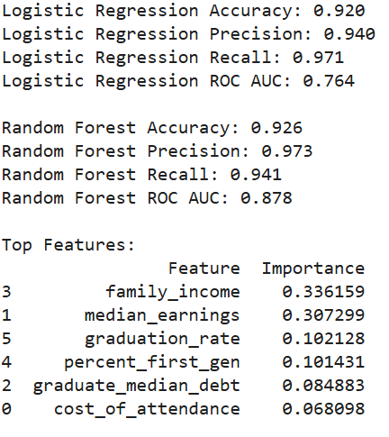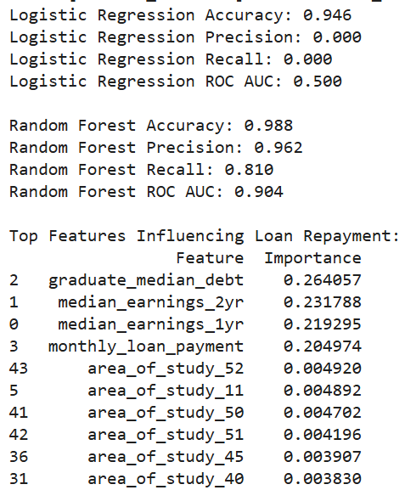
Image 6- Quality of Institution Multiple Variable Analysis Image 7- Field of Study Multiple Variable Analysis
The results of this analysis was very interesting as all areas of statistical significance increased greatly to the point of a very high degree of accuracy, precision and recall in the Random Forests. It was quite clear that neither Quality of Institution or Field of Study were good predictors of student loan repayment ability in comparison to these other factors, with only Graduation Rate scoring higher than any of them. It may come as no surprise that Family Income leads the way with Post Graduate Earnings coming close behind. The Field of Study data set showed that Amount of Student Debt and Monthly Loan Payment were also better predcitors than the two main factors considered. This clearly shows that the alternate hypothesis would need to be accepted as there are still other factors that could be analyzed that could be even better predictors than these ones tested.
Analysis of Third Research Question
The final research question posed, ‘If there is another factor that does a better job of predicting repayment, is it one the student can control and/or impact?’ which had a Null Hypothesis(H₀) of ‘If a factor is deemed to be a better predictor of student loan repayment, it is unlikely to be one that is in control of the student’ and an Alternate Hypothesis(H₁) that another factor would be found that is a better predictor and is in the student’s control. Given the results of the analysis provided when considering the first two research questions, it would be safe to say that the Null Hypothesis would be accepted here as Family Income is not in the control of the prospective students. There could be an argument made that the second best predictor, Post Graduate Earnings, would be somewhat in the control of the student as it could be tied to ability to negotiate, possibly GPA being a factor in what a student earns but that would take further research into figuring out what factors best predicted future earnings to truly be able to state that a student could be in control of it. One note to make in this area is that whether a student is a first generation postsecondary student was did not score highly and is therefore not a good predictor of student loan repayment ability, which is a positive for those hoping for student control over the results.

Conclusion
This research project will hopefully be able to rise to the level of joining the conversation regarding educating prospective students on what they need to consider before they make the commitment to take out student loans to attend college or university. As student loans appear to continue to be the way a majority of students are able to afford to attend postsecondary education institutions, this does appear to be the tip of the iceberg in terms of necessary research for students to be as well educated as possible about their likelihood of being able to pay back these loans. As Bennett and Wilezol (2013) note, “Upon graduation, a college degree today is more likely to guarantee you debt than a well-paying job”.
Recommendations
Future research in this area is extremely important for all of the reasons already mentioned. Though raw data is always the best to work with, it does become difficult to hone in on things that are in the control of the student, and therefore it may be necessary to create composite factors that would allow multiple variables to be considered together and would hopefully give stronger predictive scores that could be higher than raw factors outside the control of the prospective students.
It is also necessary to continue to flesh out hidden factors that may not be as obvious to those looking at the raw data, and see if there are factors that could be used either in composite factors, or on their own to increase predictability. Anything that can be used to increase education to those students who must take out student loans to attend postsecondary institutions is of importance to get in front of those students.
There is the possibility that the emergence of AI will allow for a more unbiased review of large amounts of data and could turn any such findings into an interactive experience for students who can then ask questions and receive education and recommendations for their college decisions based on the results of analysis instead of just the desires and feelings of young adults.

References

Arnston, L. (2024, February 2). Helping college students make informed student loan decisions. Higher Education Today. https://www.higheredtoday.org/2017/09/27/helping-college-students-make-informed-student-loan-decisions/
Bennett, W. J., & Wilezol, D. (2013). Is college worth it?: a former United States Secretary of Education and a liberal arts graduate expose the broken promise of higher education. Choice Reviews Online, 51(04), 51–2187. https://doi.org/10.5860/choice.51-2187
Black, S. E., Denning, J. T., Dettling, L. J., Goodman, S., & Turner, L. J. (n.d.). Taking it to the limit: Effects of increased student loan ... NBER. https://www.nber.org/system/files/working_papers/w27658/w27658.pdf
Dalton, S. (2004). The impact of academic performance on Post-Graduation earnings. In Centre for Newfoundland Studies, School of Graduate Studies, Faculty of Education, & Memorial University of Newfoundland, Master of Education (Leadership). https://research.library.mun.ca/10375/1/Dalton_Stephanie.pdf
Data Home | College Scorecard. (n.d.). https://collegescorecard.ed.gov/data
Ensuring ethical standards and procedures for research with human beings. (2024, January 18). https://www.who.int/activities/ensuring-ethical-standards-and-procedures-for-research-with-human-beings
Farrugia, P., Petrisor, B. A., Farrokhyar, F., & Bhandari, M. (2010). Practical tips for surgical research: Research questions, hypotheses and objectives. Canadian journal of surgery. Journal canadien de chirurgie, 53(4), 278–281.
Fitzgerald, R. A., & Burns, S. (n.d.). College quality and the earnings of recent college graduates. NATIONAL CENTER FOR EDUCATION STATISTICS. https://nces.ed.gov/pubs2000/2000043.pdf
Georgetown report emphasizes central role of postsecondary education in U.S. workforce. THE FEED. (2023, December 8). https://feed.georgetown.edu/access-affordability/georgetown-report-emphasizes-central-role-of-postsecondary-education-in-us-workforce/

GO FAIR initiative. (2022, January 21). FAIR principles - GO FAIR. GO FAIR. https://www.go-fair.org/fair-principles/
Hernon, P., & Schwartz, C. (2013). Hypotheses—An overview. Library & Information Science Research, 35(2), 85–87. https://doi.org/10.1016/j.lisr.2013.01.001
Hulley S, Cummings S, Browner W, et al. (2007). Designing clinical research. 3rd ed. Philadelphia (PA): Lippincott Williams and Wilkins
Kim, C., Tamborini, C. R., & Sakamoto, A. (2015). Field of Study in College and Lifetime Earnings in the United States. Sociology of education, 88(4), 320–339. https://doi.org/10.1177/0038040715602132Links to an external site.
National Center for Education Statistics. (n.d.). Classification of Instructional Programs (CIP 2000). https://nces.ed.gov/pubs2002/cip2000/
Polonsky, M. J., & Waller, D. S. (2019). Designing and managing a research project: A business student's guide (4th ed.). SAGE Publications.
Schmidt, K. (2023, July 4). What makes a good dataset? - KJ Schmidt - Medium. Medium. https://medium.com/@kj_schmidt/what-makes-a-good-dataset-50edea27629
Weeden, K. A. (2002). Why do some occupations pay more than others? social closure and earnings inequality in the United States. American Journal of Sociology, 108(1), 55–101. https://doi.org/10.1086/344121

.

